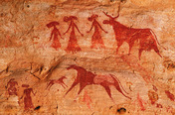
2. Hunter-Gatherer Societies

The earliest human beings appeared on Earth an estimated 2.5 million years ago. For nearly that entire time, humans lived as hunter-gatherers. They hunted wild animals and gathered edible plants. It was a simple existence. Early modern humans, who had populated much of the globe by 30,000 years ago, continued the hunting-and-gathering way of life. They lived at a time when the last Ice Age was ending. Earth's climate was cycling through a series of warm and cold periods. Sea levels rose and fell. Across great areas of Earth's surface, different forms of vegetation came and went. Humans survived by adapting to this changing environment. Like the environment, the humans, too, changed over time.
Self-Sufficiency During the Stone Age A few hunter-gatherer groups still exist today. They do not represent the great diversity of ancient hunting-and-gathering societies, but their way of life offers clues about early modern humans of the distant past. Those clues, along with evidence gathered by archaeologists, suggest that in a hunting-and-gathering economy the people were largely self-sufficient. They secured their own food supply and moved from place to place as needed to maintain it. They clothed themselves in the furs of animals that they had killed for food. They lived in caves, or they built shelters out of available materials, such as trees, brush, and animal hides. They crafted tools out of wood, bone, antlers, and stone.

Most of the materials used by ancient hunter-gatherers have disintegrated with the passage of time. The one that has survived the best is stone. When archaeologists dig at sites once inhabited by hunter-gatherers, nearly all of the tools and other artifacts that they find are made of stone. That explains the name given to the period between the emergence of stone tools and the later appearance of metal tools. Archaeologists call it the Stone Age. The Stone Age began some 2.5 million years ago. Archaeologists divide it into two major periods: the Paleolithic (“Old Stone”) and the Neolithic (“New Stone”).

Stone Age Tools When archaeologists find stone tools, they use them to gain insight into the group that produced them. By studying an ancient people's tools, they can judge how advanced the community was. The earliest hunter-gatherers' “toolkit” included stone flakes—sharp pieces of stone that could be used like knives to butcher animals. To produce them, people hit a large stone with a fist-sized stone in order to flake off pieces.
After a number of flakes had been removed, what was left of the original stone had a jagged edge. This stone tool might have served as a chopper, useful in cutting wood, cracking nuts, or breaking open bones for their marrow. It might have been used as a digger, useful for gathering edible roots. Both types of tool could also be used as weapons for hunting or for fighting.
Knowledge of how to make tools was culturally transmitted. That is, it was passed from one generation to the next. In this way it became part of the hunter-gatherer band's culture—the shared beliefs, practices, and traditions of a group.
Through much of the Stone Age, tool-making techniques developed slowly. Archaeologists identify few differences in the design of tools made during that time. Near the end of the Paleolithic period, however, some dramatic changes took place. One advance was the development of composite tools, like the spear. It combined a sharp point with a wooden shaft, for thrusting or throwing. Other tools with a variety of specific uses began to appear. For the first time, hunter-gatherers began to use needles, often made of bone, to sew their clothing. Crude flakes were now worked into thinner blades and arrowheads.
The Quest for Food Hunter-gatherers relied for survival on the natural plant and animal resources found in their surroundings. They used their tools to gather, hunt, fish, and trap those resources. In the forested areas of Europe, for example, early modern humans gathered wild fruits, nuts, roots, and seeds. In meadows and on open plains, wild cereals grew along with wild peas, beans, and other plants. Game animals included rabbits, deer, and wild pigs.
To maintain a successful hunting-and-gathering economy, these early modern humans had to be mobile. That is, they had to be able to relocate often and quickly. Hunter-gatherers moved from one place to the next in an ongoing quest for food.
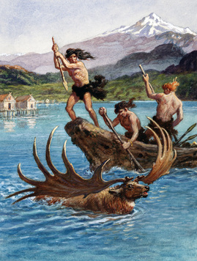
Much of their movement related to the seasonal migrations of the game animals that they hunted. They followed herds of deer and other animals as they moved from one grazing land to another. They trekked to coastal locations and rivers during the season when fish gathered there to produce and deposit eggs. They traveled to local lakes and marshes when it was time for migrating birds to stop there to feed. Gathering fruits, nuts, and other vegetative sources of food was also a seasonal affair. It, too, called for mobility.

Having to be able to move with the seasons had its limitations. Hunter-gatherers could not afford to gather possessions They had no pack animals to help them carry loads of belongings from one place to another. They had to carry everything themselves. For this reason, they took only a few tools, weapons, and other goods with them.
Mobility was a key to the hunting-and-gathering way of life. Nonetheless, later hunter-gatherers maintained “central places”—sites within their territory to which they continually returned. These base camps were usually located in a resource-rich area, perhaps along a seacoast or lakeshore or near known supplies of food or fuel. There they slept, made their tools, cooked their meals, and took part in social activities.
Interactions Within and Between Groups Hunter-gatherer bands consisted mainly of kin groups—people who claim a common ancestor. Bands typically ranged in size from 30 to 50 people. They shared food and otherwise worked together for common ends. Their economy was based on a division of labor. Men did the hunting and women did the gathering. Nonetheless, members of hunter-gatherer bands generally enjoyed equal status in the group. They had no real government—no one person had political power. But they did have leaders. These were probably elders who had the experience and personality necessary to gain the respect of the group.
Hunter-gatherers traveled far and wide to exploit available resources. The territory that they typically covered during a year might have ranged from 50 to 100 miles in diameter. Their seasonal movements sometimes led to contacts with other groups. They might have exchanged goods with those groups. But competition between groups could also lead to conflict over scarce resources. Tools might then become weapons.
Increased Social Complexity At the end of the Paleolithic period, some hunter-gatherer communities were becoming more complex. They exhibited characteristics that set them apart from traditional hunting-and-gathering groups. Their populations were higher. Their base camps were larger and tended to become near-permanent settlements. They developed equipment for processing food and systems for storing and preserving it. Some hunter-gatherers may have sowed wild seeds to expand their source of plant food. The next step for these complex societies was to begin farming the land.

A1 | How did hunter-gatherer societies  secure their food supply? | They moved from place to place in search of plants and animals for food
A2 | How did the Stone Age get its name?

B1 | How could hunter-gatherers make  use of a stone with a jagged edge?
B2 | What dramatic changes in tools took  place near the end of the Paleolithic  period?

C1 | How did early humans maintain a successful hunting-and gathering economy?
C2 | Why did hunter-gatherers have few  possessions?

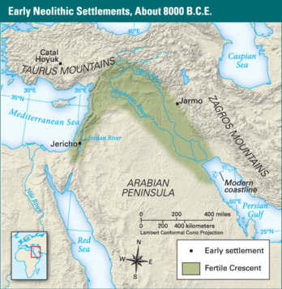
3. The Beginning of Agriculture

Complex hunter-gatherer societies appeared in regions that were rich in resources. Groups living in villages in such areas did not have to be particularly mobile. Nearly everything they needed for basic survival was available locally.
One such region existed in Southwest Asia, in the area known as the Fertile Crescent. This arc of land extended from the eastern Mediterranean across southern Anatolia (Turkey) and south to the Persian Gulf. Here, some 8,000–10,000 years ago, the first farmers appeared.
From Hunting and Gathering to Farming The western area of the Fertile Crescent, near the Mediterranean Sea, offered a wealth of natural resources. Small hunter-gatherer societies settled there. They hunted mainly gazelles but also smaller mammals and birds. They gathered fruits, tubers, and seeds—especially the seeds of wild grasses.
Farther east in the Fertile Crescent, in the foothills of the Zagros Mountains, other hunter-gatherers had a more mobile way of life. There, wild goats, sheep, and cattle migrated in the spring from the lowlands into the highlands, following the ripening pattern of the wild grasses. The hunter-gatherers moved with them, hunting the animals and gathering the seeds of the grasses.
Those grasses were the key ingredient in the momentous shift from hunting and gathering to farming. Farming involves both cultivating plants and raising animals. The first domesticated plants were grasses, in particular the large-grained cereals wheat and barley. The goats, sheep, and cattle that fed on wild grasses became the first domesticated animals (except for the dog, which had already been living with humans for thousands of years). Groups living in the Fertile Crescent also domesticated pigs.
Domestication is a biological process in which the physical characteristics of wild plants and animals change as a result of human intervention. The change likely happens over hundreds of years or more.
The following scenario suggests how hunter-gatherers might have begun domesticating wheat. Of two varieties of wild wheat, one dropped its ripened seeds when touched. That made it hard to harvest. Hunter-gatherers learned to collect only the variety that kept its seeds. That way, they could harvest the wheat by cutting the stalks and carrying them back to their village for processing. They saved and later sowed some of that same seed, intending to expand the resource in the wild. As a result, that one variety of seed began to dominate the local stands of wild wheat. Through this process, hunter-gatherers unintentionally changed the overall traits of the wheat in their territory.
In time, hunter-gatherers in the Fertile Crescent began to make these kinds of choices intentionally.
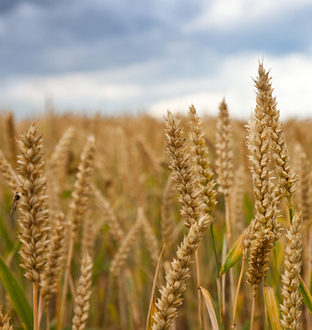
• They selected plants, as well as animals, that had favorable characteristics.
• By around 9,000 years ago, they were cultivating wheat— preparing the ground and then sowing and harvesting the seeds. They also grew barley, lentils, chickpeas, peas, and beans.
• They built structures for storing their food.
• Near their fields, they built houses, which together formed a farm village.
• They may have continued to hunt or to gather, but eventually, most came to rely on their domesticated plants and animals to provide for their basic needs.
• They were sedentary—they stayed in one place, in permanent, year-round settlements.
• They had become farmers.
Later, some groups moved away from the centers of farming to take up a herding way of life. On the grasslands of the Fertile Crescent, they lived with their herds of domesticated sheep, goats, and cattle. Periodically, they moved with the herds as the animals moved to fresh pastures. People who establish this kind of food-producing economy are called pastoral nomads. The nomadic herders of the Fertile Crescent likely preferred life in the wide-open spaces to life in the farm villages.
Why Agriculture Arose Increased knowledge of how to domesticate plants and animals is just one reason scholars give for why agriculture began when it did. They also note the development of new technology for gathering, processing, and storing foods. Another important factor is climate. The last Ice Age ended around 11,500 years ago. After that time, Earth's climate remained generally stable. In the Fertile Crescent and other places in which farming began, the climate turned favorably warm and rainy. Yet another reason for the rise of agriculture was population pressures. As populations increased, hunter-gatherers needed to expand their supply of food. Farming met this need.


The Spread of Agriculture In 10,000 B.C.E., nearly every human was a hunter-gatherer. By 1 C.E., most were either farmers or herders. The shift from hunting and gathering to agriculture, once it had started in any location, took hundreds or thousands of years. During the transition, groups acquired needed resources through a mix of hunting, gathering, farming, and herding.

Agriculture first appeared in the Fertile Crescent around 9,000 years ago. Through cultural diffusion, it spread from there to Egypt, Europe, and India. Knowledge of agriculture might have been carried to those places by pastoral nomads, some of whom were also skilled farmers. These mobile peoples were free to travel far from their home territory, wherever there was grass to feed their herds. Another way that agriculture spread was through the migration of farming peoples.
By 8,000 years ago, rice and millet were being domesticated in China. By 5,500 years ago, maize (corn) was being domesticated in the Americas, followed about a thousand years later by llamas. Agriculture appears to have arisen independently in these two places, as well as in sub-Saharan Africa and elsewhere.
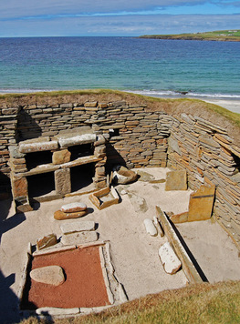
The Impact of the Shift to Agriculture The shift to agriculture ushered in the Neolithic period, or New Stone Age. Neolithic peoples developed new technologies to feed the ever-growing population. They crafted better stone tools, such as the stone-bladed plow for tilling the soil. They created pottery for storing food and decorated it with distinctive styles. In time, they invented the wheel, which served as a turntable for pottery-making and was a landmark improvement in transportation.
The expansion of agriculture changed people's relationship to the environment. Instead of drawing resources from an extensive territory, as hunter-gatherers did, farmers cultivated a small area intensively. In wooded regions, farmers cleared the ground through slash-and-burn methods. They chopped down trees and set fire to any remaining vegetation.
The rise of agriculture also had an important social impact. The population density—the number of people in a unit of area—rose as kin groups came together in farm villages. Humans, now sedentary, began to accumulate goods, sometimes in exchange for surplus crops. These included not just practical goods such as pots and grinding stones but also beads and bracelets made of imported shells and precious stones. Ownership of such luxury goods brought respect and signaled a family's wealth, as did the amount of land it farmed or the size of its herd.
Wealth gave individuals power. It sets them apart from others. Instead of the equality that characterized hunter-gatherer societies, farming villages gradually became stratified. People were divided into status groups based largely on wealth.
The shift from hunting and gathering to agriculture is often called the Agricultural Revolution. Some scholars refer to it as the Neolithic Revolution to suggest that its impact went beyond farming. Whatever the name, this shift was, indeed, revolutionary. In the past, advances in human knowledge tended to remain within each isolated hunter-gatherer culture. Now technological and social innovations could be passed easily not only from one generation to the next but from one culture to another.
-

D1 | What plants were the first to be domesticated?
D2 | How did hunter-gatherers change to a sedentary lifestyle?

E1 | Why did agriculture arise when it did?
E2 | What important social impact did the rise of agriculture have?

F1 | How did agriculture spread from the Fertile Crescent?
F2 | How did agriculture come to China, the Americas, and sub-Saharan Africa?

4. The Rise of Civilizations
Settlements that arose during the Neolithic period grew in population and social complexity. Villages became towns. Over time, towns became cities. In a few of the world's river valleys, humans took the next step. Actually, they took an enormous jump. They developed the first civilizations.
Characteristics of a Civilization A civilization is a highly organized and complex society. This definition, however, is a bit too tame for historian Michael Cook. He declares that “the term civilization suggests that there is in fact some kind of quantum leap in complexity.”
One “quantum leap” involved the development of writing. Before the rise of the first civilization, writing did not exist. The names of people, places, and events were not recorded. Humans had the necessary tools—sticks and brushes, inks and paints. But they needed something much more abstract. To acquire writing, a society had to find a way to represent spoken language with visual symbols. Each of the world's earliest civilizations managed to do this.

Ancient civilizations commonly shared several other characteristics besides writing. One was geography. Ancient civilizations arose in river valleys, where access to water and fertile soil made farming much more productive.
Another characteristic of ancient civilizations was large cities. Unlike agricultural villages, populated by related families, cities drew a wide mix of peoples from the surrounding region. Usually, the urban social system evolved into a hierarchy—a ranking of groups of people according to their importance, status, or power. One person, the king (or priest-king), held the top rank.
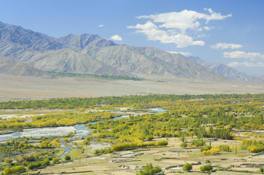
Most cities contained large public structures—palaces for kings and temples for priests—as well as markets for the exchange of goods. Rulers typically managed the economy, supporting state activities by taxing farmers, merchants, and artisans or by forcing people to labor for the state.

Why Civilizations Arose Each of the major early civilizations developed in a unique way. Scholars have found no single cause that explains why they arose. Instead, they cite a number of factors that worked together to bring about civilizations.
• Access to Water Complex states formed, in part, as a result of the success of agriculture. Irrigation played a key role in that success. The first civilizations developed in fertile river valleys, where farmers built canals and other structures to carry river water to their fields or to store floodwater. Ready access to water greatly improved crop yields—the amount of food that could be grown per acre. Plentiful food led to expanding populations. Settlements eventually became cities.
• Government As a settlement's population increased, its society changed in a number of ways. One way related to government. Some societies replaced rule by elders with rule by a central authority, the state. The state, run by the king and a multitude of trained officials, was better able to organize and coordinate the activities of the increasingly more complex society.
• Defense Growing communities competed with one another for resources. Competition could lead to conflict. For defensive purposes, large settlements built walls around themselves to ward off invaders. Kings sometimes gained power through their success in battle. But they took responsibility for the society's prosperity as well as its defense.
• Specialized Jobs With advances in agriculture, farmers were able to grow more than the society could consume, which meant that everyone did not have to be a farmer. Food surpluses supported those who chose to specialize, full-time, in other areas. They became artisans and warriors as well as priests and government officials.
• Trade Some became merchants, or traders. Growing settlements found that they could not produce all the resources that people needed or wanted. They engaged in long-distance trade both for necessities, such as raw materials, and for luxury goods. Having a steady supply of goods helped settlements grow, and thus trade was yet another factor in the rise of civilizations.

G1 | How do we define civilization?
G2 | What characteristics did ancient  civilizations share?

H1 | What role did water play in the rise  of civilizations?
H2 | Why did some societies develop  governments?

I1 | How did societies develop specialized jobs, such as artisans, warriors, and priests?
I2 | How did trade develop?

